

**CIRC-SA2**

**Server Access and LCD**

**(Designed by: *Theo Stangebye*, Josiah Talampas, Jacob Eisenhart, Mitchel Miller, & Michael Moldovan**

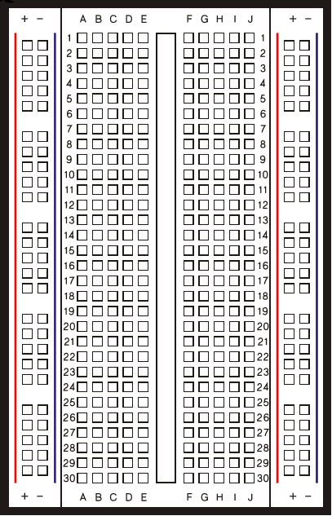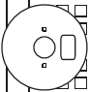

**CIRC-MC1**

**Morse Code Input**

**(Designed by*: Josiah Talampas*,**

**Theo Stangebye, Jacob Eisenhart, Mitchel Miller, & Michael Moldovan**

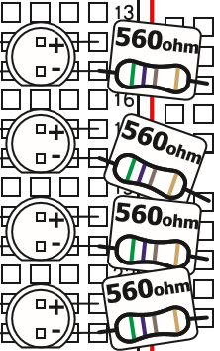

z

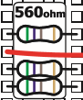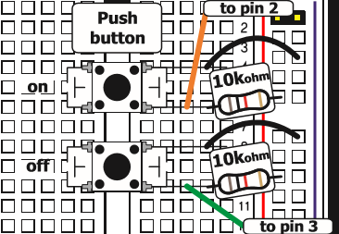

**LCD Screen**

**to pin 5**

**to pin 7**

**to pin 6**

**to Gnd**

**to 5v**

**to A4**

**to A4**

**to Gnd**

**to Gnd**

**to A5**

**to A5**

**Arduino board of MC1 is connected to an Ethernet shield on Arduino board of SA2.**